1. **INTRODUCTION**

**1.1 MOTIVATION:**

This document aims to give a brief description about E-Commerce web application using angular, Spring Boot and Mongo db. The main aim of this project is to build an E-commerce website of home décor items in the Covid situation where all the offline shops are closed. E-commerce is fast gaining ground as an accepted and used business paradigm. More and more business houses are implementing web sites providing functionality for performing commercial transactions over the web. It is reasonable to say that the process of shopping on the web is becoming commonplace. The objective of this project is to develop a general purpose e-commerce store where product like clothes can be bought from the comfort of home through the Internet. However, for implementation purposes, this paper will deal with an online shopping for clothes. An online store is a virtual store on the Internet where customers can browse the catalog and select products of interest. The selected items may be collected in a shopping cart. At checkout time, the items in the shopping cart will be presented as an order. At that time, more information will be needed to complete the transaction. Usually, the customer will be asked to fill or select a billing address, a shipping address, a shipping option, and payment information such as credit card number. An e-mail notification is sent to the customer as soon as the order is placed.

**1.2 PROBLEM STATEMENT:**

During this pandemic time it has been difficult to shop offline with the fear of spreading of corona virus. Hence many offline home décor shops have been closed due to no visitors. Almost all small businesses have been paused due to the pandemic. Hence there must be a way created for these small businesses to run even in these pandemic times so that they don’t have to bear huge loss.

Shop For Home is a popular Store in the market for shopping the home décor stuff .Due to Covid 19 all the offline shopping stopped. So, the store wants to move to the online platforms and wants their own web application.

There are 2 users on the application:

1. User

2. Admin

**1.3 SOLUTION:**

Hence E – commerce web application came into picture. Where the vendors can sell their products online so that customers don’t have to travel during these hard times and the business will be continued to run.

**1.4 SCOPE OF THE PROJECT:**

Online selling and purchasing offer innumerable benefits to both sellers and buyers, and these advantages are also the reasons for the rising scope of e-Commerce. As of 2017, the total value of the e-commerce business in India was USD 38.5 billion, according to IBEF, and it is expected to hit USD 200 billion by 2026. That gives us a good idea about the future scope of e-commerce in India.

**1.5 PROBLEM DEFINITION:**

E-commerce provides an easy way to sell products to a large customer base. However, there is a lot of competition among multiple e-commerce sites. When users land on an e-commerce site, they expect to find what they are looking for quickly and easily. Also, users are not sure about the brands or the actual products they want to purchase. They have a very broad idea about what they want to buy.

**1.6 OBJECTIVES:**

The primary goal of e-commerce is to reach maximum customers at the right time to increase sales and profitability of the business. Functions of e-commerce include buying and selling goods, transmitting funds or data over the internet.

The three main objectives are as follows

1. Find the best solution for their needs
2. Make a purchase, and
3. Get information/answers to their questions

**2. OVERALL DESCRIPTION**

**2.1 PRODUCT PERSPECTIVE**

Home décor shop is aimed towards the vendors who want to reach out to the maximum cross-section of customer and common people who can be potential customer. This project envisages bridging the gap between the seller, the retailer and the customer. OFS should be user- friendly, ‘quick to learn’ and reliable software for the above purpose. OFS is intended to be a stand-alone product and should not depend on the availability of other software. It should run on both UNIX and Windows based platform

**2.2 USER CLASSES AND CHARACTERISTICS**

The user should be familiar with the Shopping Mall related terminology like Shopping cart/Checking out/Transaction etc.

The user should be familiar with the Internet.

**2.3 OPERATING ENVIRONMENT**

The product will be operating in windows environment. Home décor online shop system is a website and shall operate in all famous browsers, for a model we are talking Microsoft Internet Explorer, Google Chrome and Mozilla Firefox. Also it will be compatible with the IE 6.0. Most of the features will be compatible with the Mozilla Firefox and Opera 7.0 or higher version. The only requirement to use this online product would be the internet connection. The hardware configuration include Hard Disk: 40GB, Monitor: 15 inch Color monitor, Keyboard: 122 keys. The basic input devices required are keyboard, mouse and output devices are monitor etc

**2.4 OVERVIEW:**

A E-commerce website that allows people to buy and sell physical goods, services, and digital products over the internet rather than at a brick-and-mortar location. Through an e-commerce website, a business can process orders, accept payments, manage shipping and logistics, and provide customer service.

**2.5 PRODUCT FUNCTIONS**

1. **User-Friendly Design**

Perhaps the most important feature customers want in an ecommerce site is a good user experience. If your customers can’t find their way around your website or they struggle to find what they’re looking for, they will likely move swiftly on to one of the many other online retailers. Utilize ecommerce UX best practices. Prioritize customer experience by: Creating a simple, straightforward, high-quality homepage. Including a search bar. Clearly listing category pages in the navigation bar. Focusing on creating a responsive website. 14 Modern Website Design Trends for 2022

1. **Mobile-Friendly Features**

In the modern marketplace, ecommerce consumers are increasingly reliant on their mobile devices. According to SaleCycle, mobile devices were used in 56% of all online purchases in 2020. In other words, most customers want to browse online stores on their phones, so including mobile optimization in your ecommerce website design is vital. Ensure your web design is automatically modified for the screen size and shape of phones to increase your conversion rate and keep customers happy.

1. **Multiple Payment Options**

Shopping cart abandonment is often a big issue for online retailers. To improve your chance of sealing the deal in the final checkout process on your website, be sure to make the purchasing stage as easy as possible for your customers by offering multiple online payment methods in the shopping cart. In addition to offering debit and credit card options, consider adding options for payment providers like PayPal or Stripe. You could also add plugins that have a buy now, pay later functionality to encourage customers to press the “purchase” button.

1. **24/7 Customer Service**

A big part of a successful customer experience is providing helpful, accessible customer service. According to Microsoft, 90% of Americans consider customer service an important feature when deciding whether or not to purchase from a company. Include a 24/7 customer service chatbot as one of your ecommerce website features to address customer needs at any time. Plugins like Zendesk or LivePerson make it easy for you to add this feature to your website for a small fee.

1. **User Discounts Customers**

like to feel that they’re getting a good deal and being treated differently from other customers. Offer personalized deals, offers, and other user features to give them this type of attractive, customized experience. Offer user accounts where customers can access loyalty pricing offers, their personalized wishlist, and account history. You can also use an ecommerce platform automated emailing system to send targeted special offers to loyal customers.

1. **Extensive Product Information**

Shopping online has become extremely common, but many consumers still feel hesitant about making online purchases — especially from smaller brands that they may be unfamiliar with. A big disadvantage of online shopping for consumers is that they are unable to see or try the product before making a purchase. In order to convince your customers that your product is high-quality and worth their money, be sure to offer as much product information as possible. On your product pages, include detailed product descriptions that offer information about size, material, color, ingredients, and place of origin. Offer high-quality product photography that show the product from every angle. For clothing, be sure to include images of a model wearing the item.

**2.6 Approportioning of Requirements**

As stated by the customer, security is not a concern of this project. As such, it is beyond the scope of this system to encrypt personal user data, encrypt credit card information, prevent unauthorized login attempts, or any other concern of this nature. Additionally, the system is not responsible for the following:

• Verifying that credit card information is valid

• Verifying the email address provided by a user

• Storing additional information about a product beyond simply the category and price • Allowing users to edit their account details (username, password, mailing address, etc)

• Allowing customers to order multiple copies of product in a single order

• Providing individual product description

• Allowing the Admin to update login credentials or other information about the Admin.

**3. SPECIFIC REQUIREMENTS**

**3.1 FUNCTIONAL REQUIREMENTS**

**User Stories –**

1. As a user I should be able to login, Logout and Register into the application.
2. As a user I should be able to see the products in different categories.
3. As a user I should be able to sort the products.
4. As a user I should be able to add the products into the shopping cart.
5. As a user I should be able to increase or decrease the quantity added in the cart.
6. As a user I should be able to add “n” number of products in the cart.
7. As a user I should be able to get the Wish list option where I can add those products which I want but don’t want to order now.
8. As a user I should get different discount coupons.

**Admin Stories –**

1. As an Admin I should be able to login, Logout and Register into the application.
2. As an Admin I should be able to perform CRUD on Users.
3. As an Admin I should be able to Perform CRUD on the products.
4. As an Admin I should be able to get bulk upload option to upload a csv for products details
5. As an Admin I should be able to get the stocks.
6. As an Admin I should be able to mail if any stock is less than10.
7. As an Admin I should be able to get the sales report of a specific duration.
8. As an Admin I should be able to set the discount coupons for the specific set of users

**3.2 SOFTWARE REQUIREMENTS:**

The functional requirements or the overall description documents include the product perspective and features, operating system and operating environment, graphics requirements, design constraints and user documentation.

The appropriation of requirements and implementation constraints gives the general overview of the project in regards to what the areas of strength and deficit are and how to tackle them.

| **Technologies** | **Angular, Spring Boot, MySQL** |
| --- | --- |
| **Languages** | **Type Script, Java, SQL Querries** |
| **IDE** | Eclipse , Vs code, Postgresql |
| **Operating System** | Windows 7/8/10/11 , Linux distros, MacOS X or later. |

**3.3 HARDWARE REQUIREMENTS:**

Minimum hardware requirements are very dependent on the particular software being developed by a given Enthought Python/ VS Code user. Applications that need to store large arrays/objects in memory will require more RAM, whereas applications that need to perform numerous calculations or tasks more quickly will require a faster processor.

| **Processor** | Intel or AMD dual core x86 processor. |
| --- | --- |
| **Ram** | 2 GB or above. |
| **Hard disk** | 500 MB of free disk space or more. |

**3.3 ARCHITECTURE**

**Angular Architecture:**

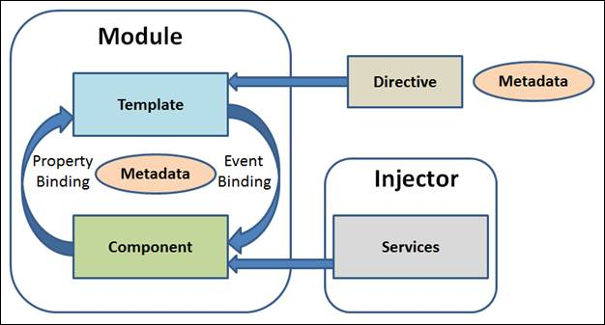

**Fig. 3.1 Angular Architecture**

There are main eight blocks of Angular.

1. Module
2. Component
3. Metadata
4. Template
5. Data Binding
6. Service
7. Directive
8. Dependency Injection

**Spring Boot Architecture:**

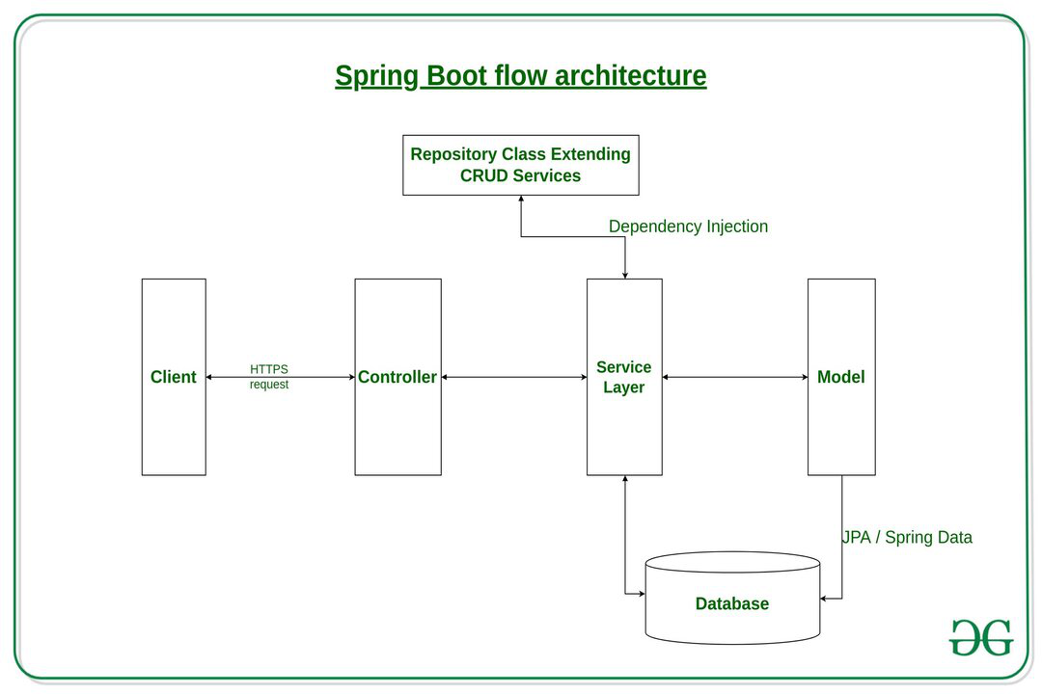

**Fig. 3.2 Spring Boot Architecture**

The spring boot consists of the following four layers:

1. Presentation Layer – Authentication & Json Translation
2. Business Layer – Business Logic, Validation & Authorization
3. Persistence Layer – Storage Logic
4. Database Layer – Actual Database

**Micro Services Architecture**

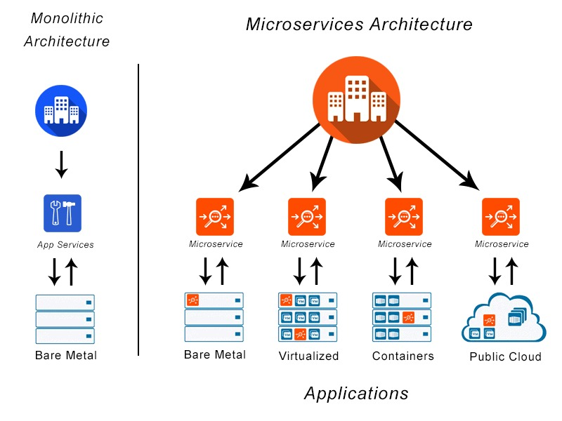

**Fig 3.3 Microservices Architecture**

Typically, microservices are used to speed up application development. Microservices architectures built using Java are common, especially Spring Boot ones. It’s also common to compare microservices versus service-oriented architecture. Both have the same objective, which is to break up monolithic applications into smaller components, but they have different approaches

**DataBase Design:**

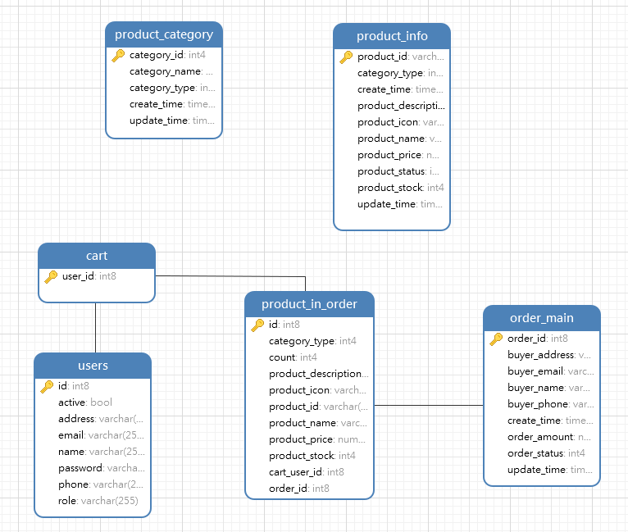

Tables are created for all entities

Entities in the Database include

1. Product_Category
2. Product_info
3. Cart
4. Users
5. product_in_order
6. Order_main

**3.3 NON FUNCTIONAL REQUIREMENTS**

### **Usability:**

Regardless of the size of your business, the website of your business should be easy to use for even a non-technical user. Do you know that a general user takes just 0.05 seconds to figure out whether the website is worth its time or not? Thus you have to give special attention to the design of your homepage, CTAs, and easy checkout to get past those milliseconds of doom. The usability of a website is also defined by:

* How easily a user can achieve their target in a single page visit
* How quickly they can perform tasks in the store
* The memorable & intuitiveness of the design
* Number and types of errors users make

### **Security:**

Security comes with utmost importance if your site is dealing with monetary transactions, users’ financial and sensitive data. Using an SSL certificate and data privacy policy will create trust among the users for your website and convert the customers into brand advocates. It is also considered for the different admin roles by which you can control who can create, see, copy, change or delete information. Depending upon the location of your business, security also refers to compliance with customer data protection rules such as GDPR in Europe.

### **Performance:**

For increasing the traffic on your website, you have to give special attention to the performance in the non-functional requirements documentation. The focus should be on loading the e-commerce store as fast as possible regardless of the number of integrations and traffic on your website. You can set up the speed benchmark, maximum SKUs which you want to add, or any other performance indicator best for your business. Don’t consider the 3rd party system delivery time, because the developers will not have control over the 3rd party API calls.

1. **Maintainability:**

The operational costs for maintenance are the tricky part of planning a business budget. Thriving the website maintenance from the initial development means cutting the time & cost to determine and resolve the faults of the system in the future. Well, it sounds sad but there is no way to avoid issues in the future and you have to look for a website development company that can maintain your website.

1. **Scalability:**

Last but not the least, you have to look for a future-proof solution considering the scalability. It will define how the website can grow and increase its features and functionality without impacting the performance of your website. You must be able to add more memory, servers, or disc space for making more transactions on your website. On the server side, while entering new markets you may need to add localization features. Overall, this NFR accounts for painless business expansion and has both hardware and software implications.

* 1. **MODELING REQUIREMENTS**

**4.1 UML DIAGRAMS :**

UML stands for Unified Modeling Language. UML is a standardized general-purpose modeling language in the field of object-oriented software engineering. The standard is managed, and was created by, the Object Management Group.

The goal is for UML to become a common language for creating models of object oriented computer software. In its current form UML comprises two major components: a Meta-model and a notation. In the future, some form of method or process may also be added to; or associated with, UML.

The Unified Modeling Language is a standard language for specifying, Visualization, Constructing and documenting the artifacts of software systems, as well as for business modeling and other non-software systems.

The UML represents a collection of best engineering practices that have proven successful in the modeling of large and complex systems.

The UML is a very important part of developing objects oriented software and the software development process. The UML uses mostly graphical notations to express the design of software projects.

GOALS:

The Primary goals in the design of the UML are as follows:

1. Provide users a ready-to-use, expressive visual modeling Language so that they can develop and exchange meaningful models.

2. Provide extendibility and specialization mechanisms to extend the core concepts.

3. Be independent of particular programming languages and development processes.

4. Provide a formal basis for understanding the modeling language.

5. Encourage the growth of the tools market.

6. Support higher level development concepts such as collaborations, frameworks, patterns and components.

7. Integrate best practices

**4.1.1 USE CASE DIAGRAM**

A use case diagram in the Unified Modeling Language (UML) is a type of behavioral diagram defined by and created from a Use-case analysis. Its purpose is to present a graphical overview of the functionality provided by a system in terms of actors, their goals (represented as use cases), and any dependencies between those use cases.

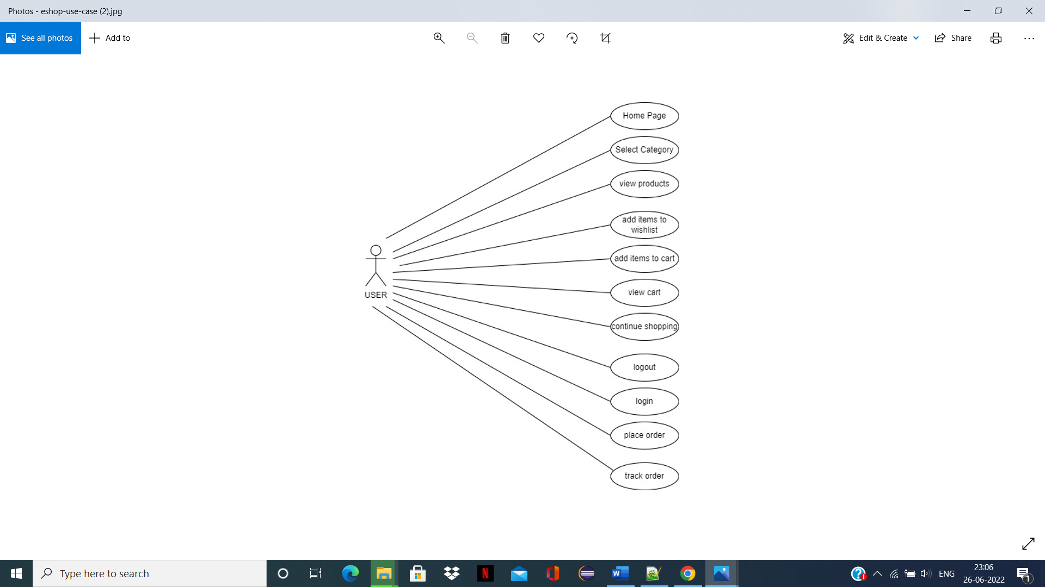

**Fig. 4.1 Use Case Diagram**

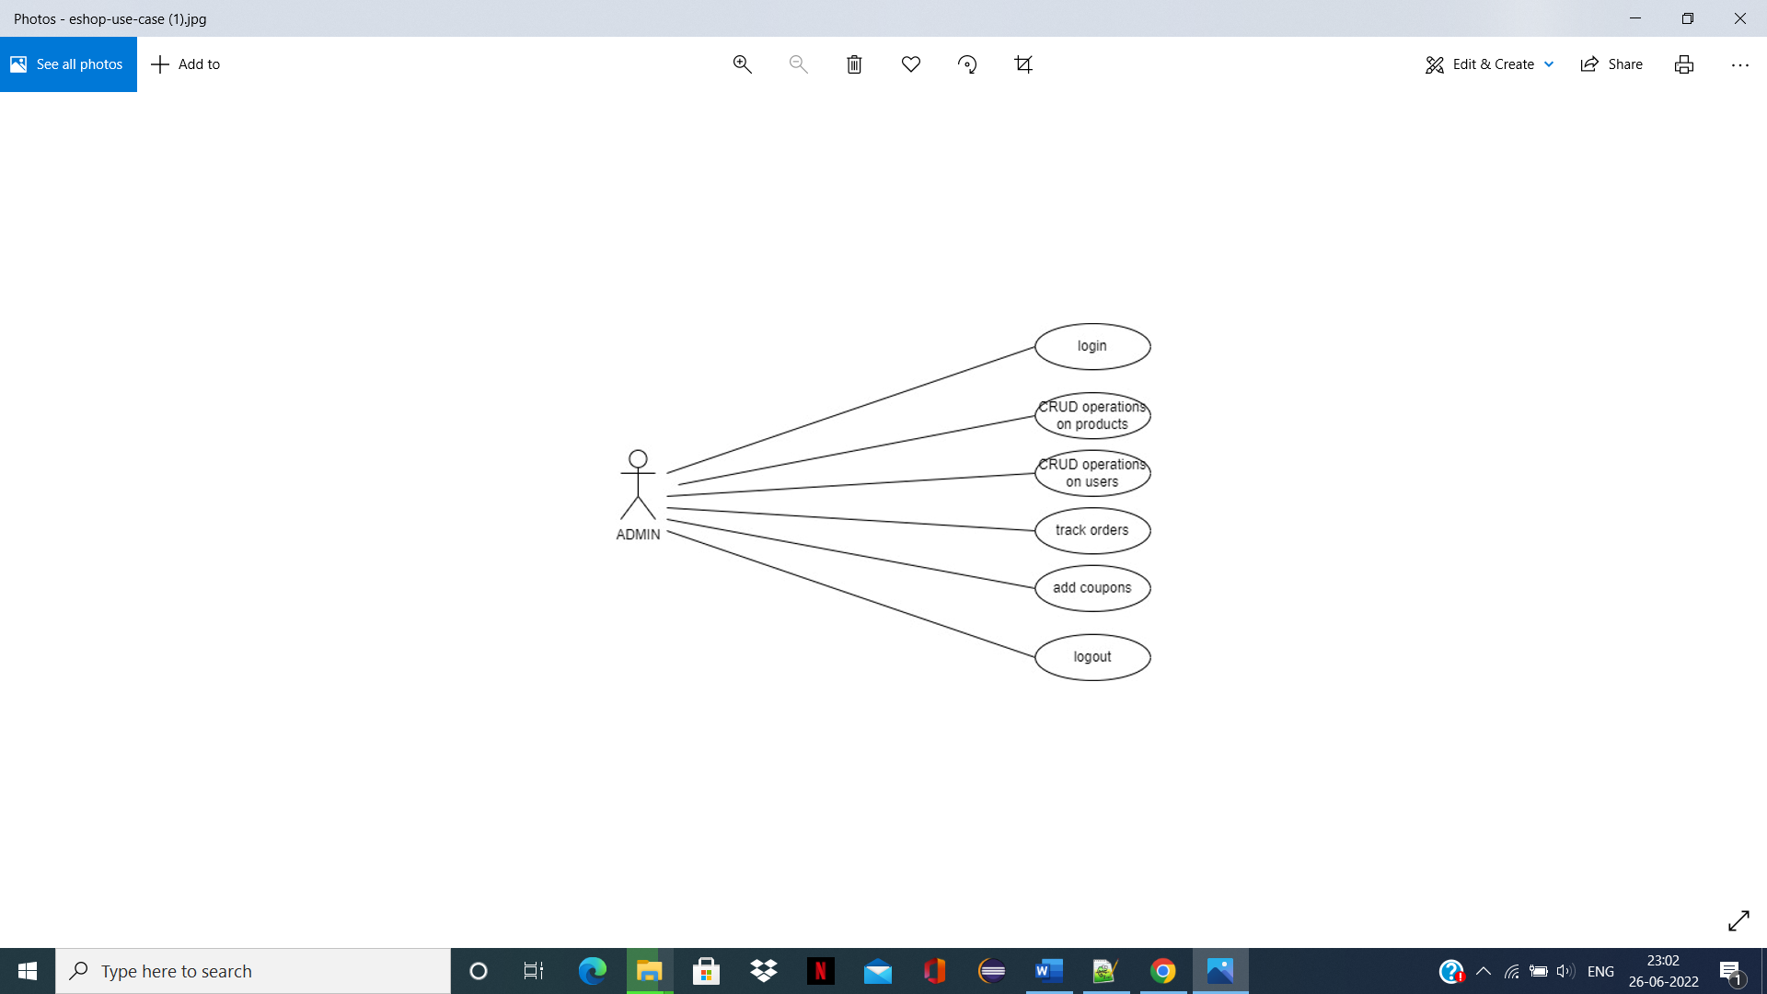

**Admin Functionality**

**4.1.2 CLASS DIAGRAM**

The class diagram is used to refine the use case diagram and define a detailed design of the system. The class diagram classifies the actors defined in the use case diagram into a set of interrelated classes. The relationship or association between the classes can be either an "is-a" or "has-a" relationship. Each class in the class diagram may be capable of providing certain functionalities. These functionalities provided by the class are termed "methods" of the class.

Apart from this, each class may have certain "attributes" that uniquely identify the class.

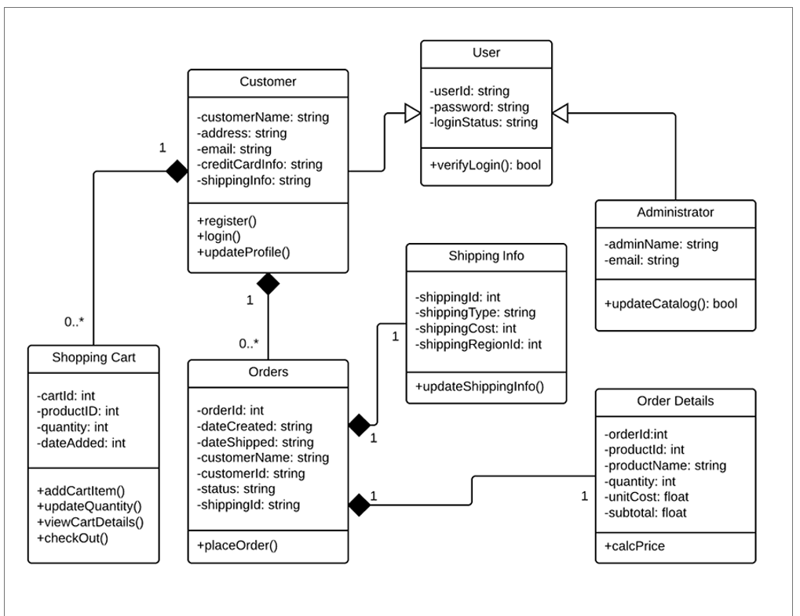

**Fig. 4.2 Class Diagram**

**4.1.3 STATE CHART DIAGRAM**

A state diagram, as the name suggests, represents the different states that objects in the system undergo during their life cycle. Objects in the system change states in response to events. In addition to this, a state diagram also captures the transition of the object's state from an initial state to a final state in response to events affecting the system.

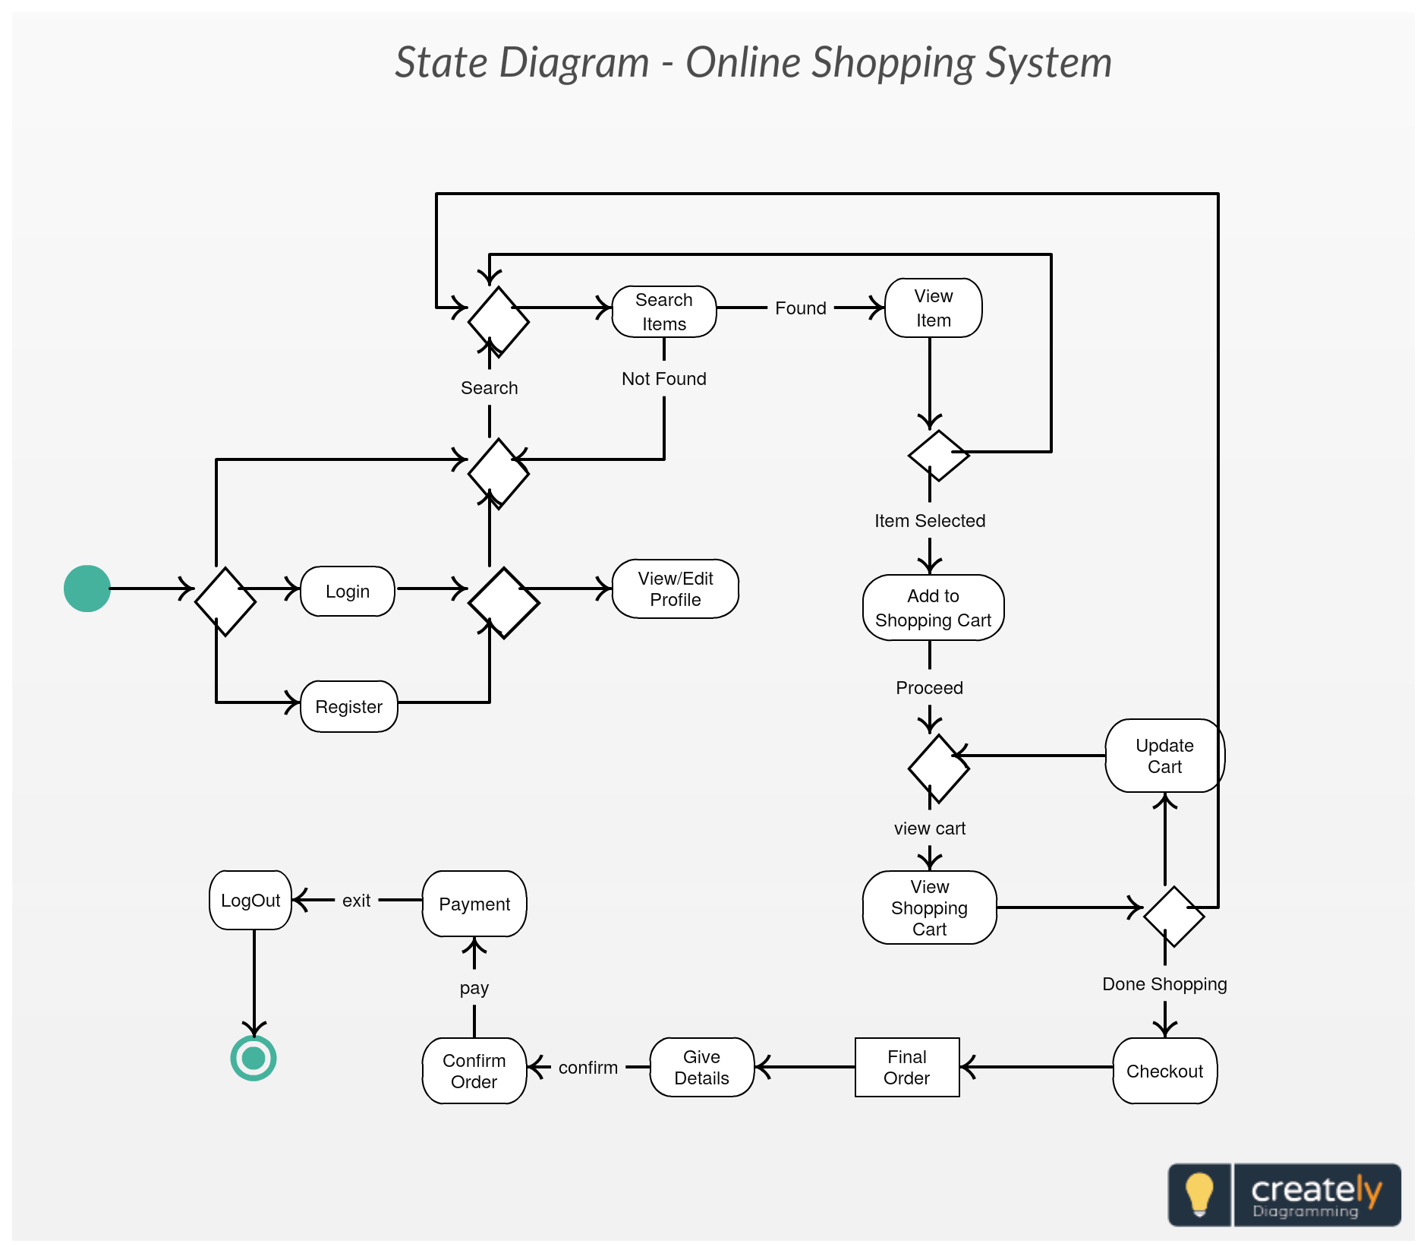

**Fig. 4.3 State Chart Diagram**

**4.1.4 ACTIVITY DIAGRAM :**

The process flows in the system are captured in the activity diagram. Similar to a state diagram, an activity diagram also consists of activities, actions, transitions, initial and final states, and guard conditions.

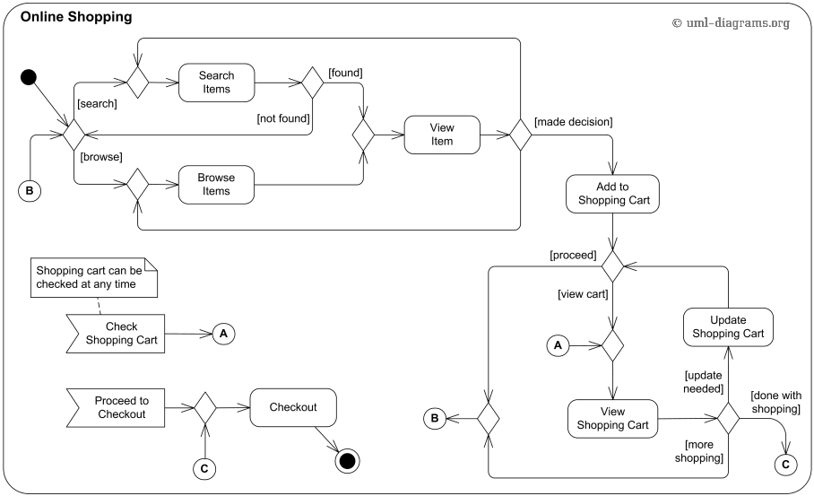

**Fig. 4.4 Activity Diagram**

**4.1.5 SEQUENCE DIAGRAM :**

A sequence diagram represents the interaction between different objects in the system. The important aspect of a sequence diagram is that it is time-ordered. This means that the exact sequence of the interactions between the objects is represented step by step. Different objects in the sequence diagram interact with each other by passing "messages".

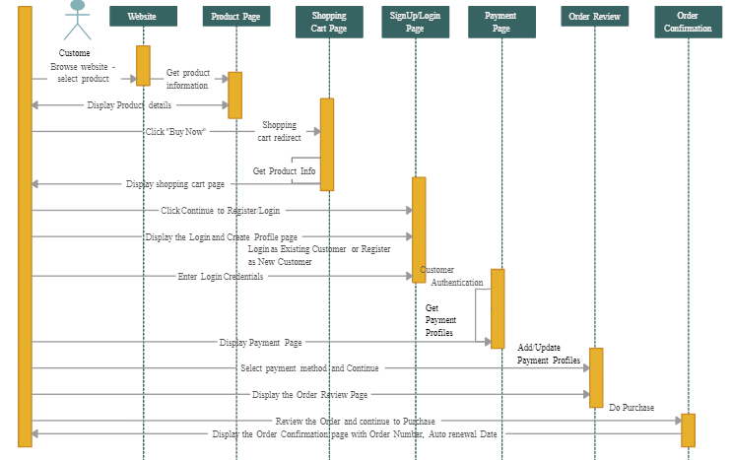 **Fig. 4.5 Sequence Diagram**

**4.3 DATA FLOW DIAGRAM**

The flow chart diagram is a special kind of class diagram. The flow chart diagram depicts the flow of the process or algorithm using a set of symbols. The flow chart diagram is a pictorial representation of the algorithm or working of the algorithm.

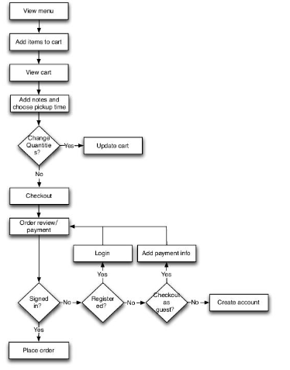

**Fig 4.6 Data Flow Diagram**

**5. IMPLEMENTATION**

We will implement a simple e-commerce application. We'll develop an API using Spring Boot and a client application that will consume the API using Angular. Basically, the user will be able to add/remove products from a product list to/from a shopping cart and to place an order.

**5.1 TECHNOLOGY USED**

In below I would like to explain which technologies are used in this project. It’s helpful for understand the project layouts & overview of documentation.

### **Back-end**

1. Java
2. Spring Boot
3. Spring Security
4. JWT
5. Hibernate
6. PostgreSQL
7. Maven

### **Front-end**

1. Angular
2. Bootstrap

**5.2 IMPLEMENTATION STEPS**

First you need to start back-end server, after that execute client side. Follow below steps to run this application on your system.

1. First Install Java 11 jdk, Vs code, Eclipse, PostgresSQL
2. From your local FrontEnd code path -> open cmd

Eg -> {local path}\ecommerce-eshop\frontend

1. Run this command -- **code .**
2. Run **Npm install** from vs code terminal
3. Run npm start
4. After the successful compiling you got this link in terminal localhost/4200.
5. Open this link in google chrome

DataBase

1. Install postgres SQL
2. After installation serach PgAdmin in your computer
3. Open that PgAdmin
4. Open this query editor and You can run the querry from sql file.
5. Run the query.

**6. RESULT AND DISCUSSION**

**FRONT END SCRENSHOTS**

FRONT END STRUCTURE:

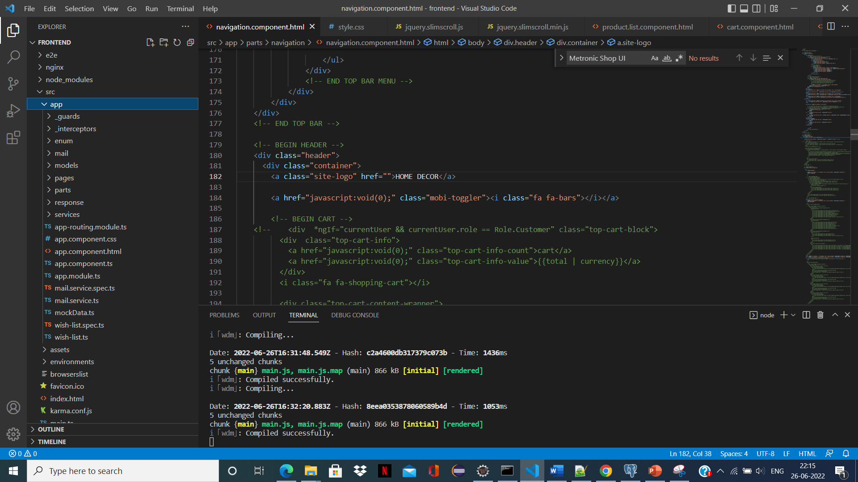

VS Code page

**USER FUNCTIONALITY:**

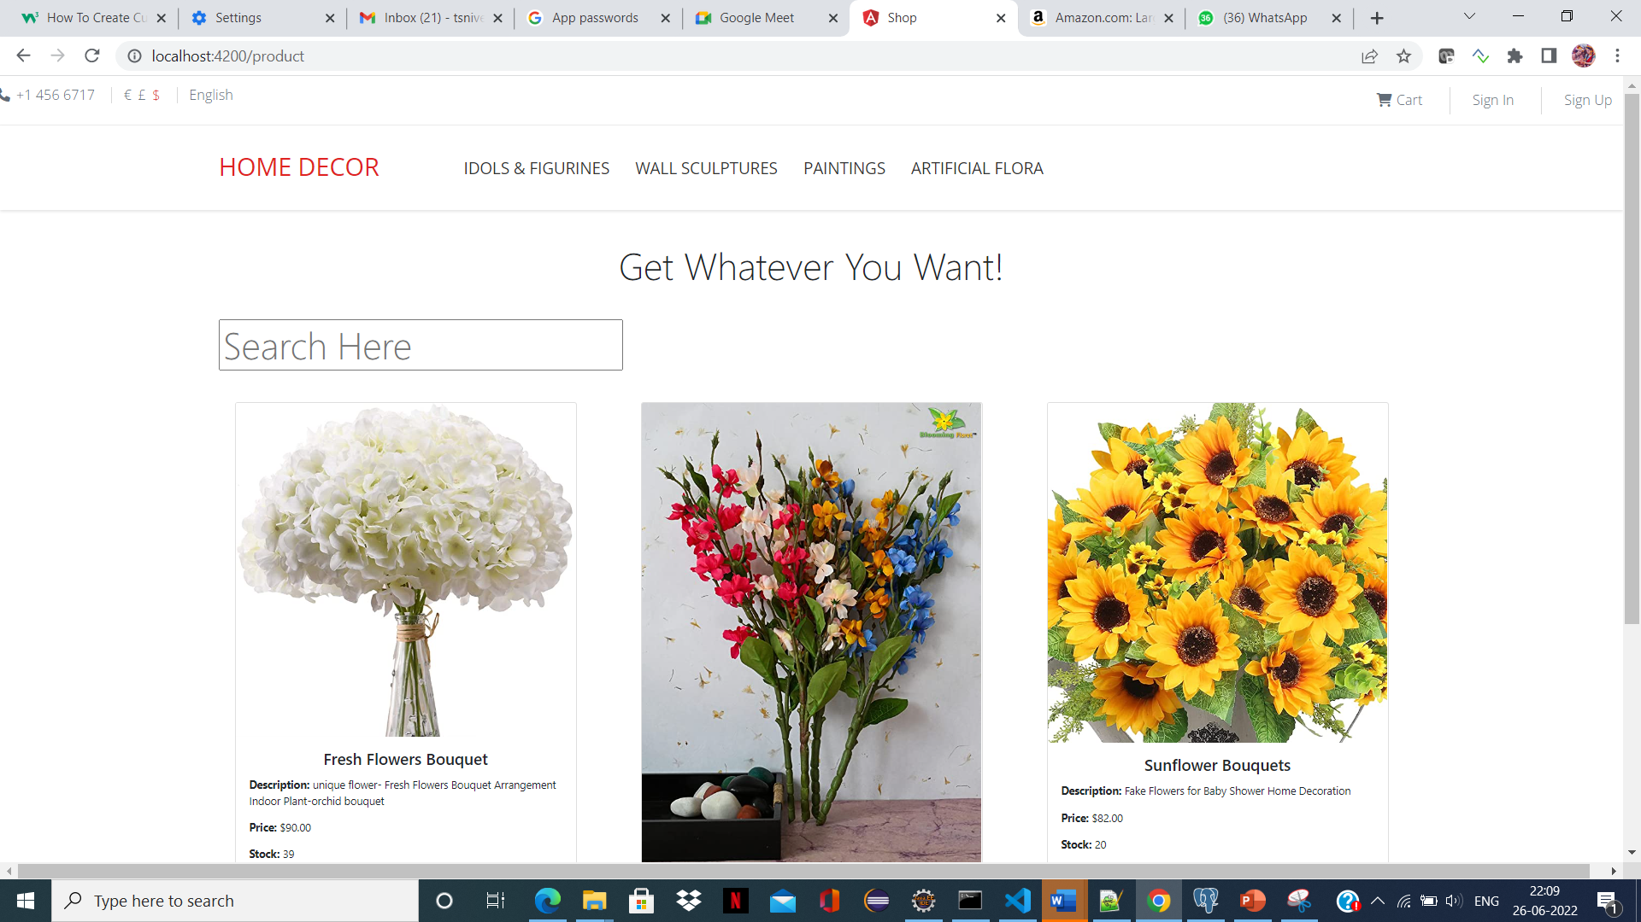

Home page

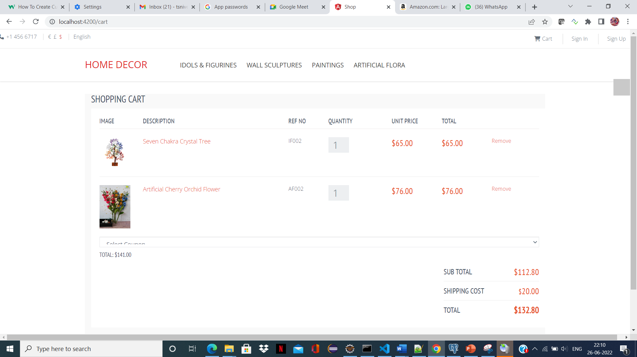

Cart page

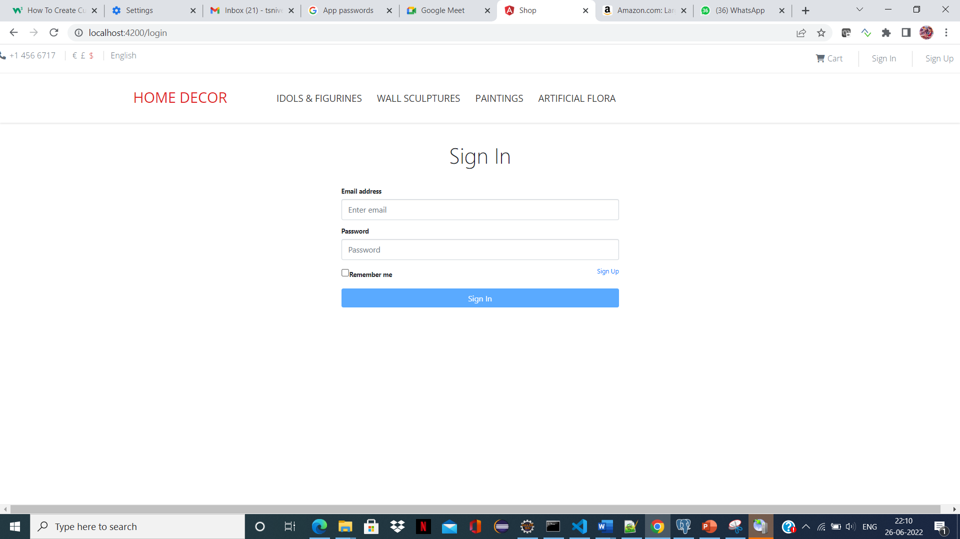

Sign In page

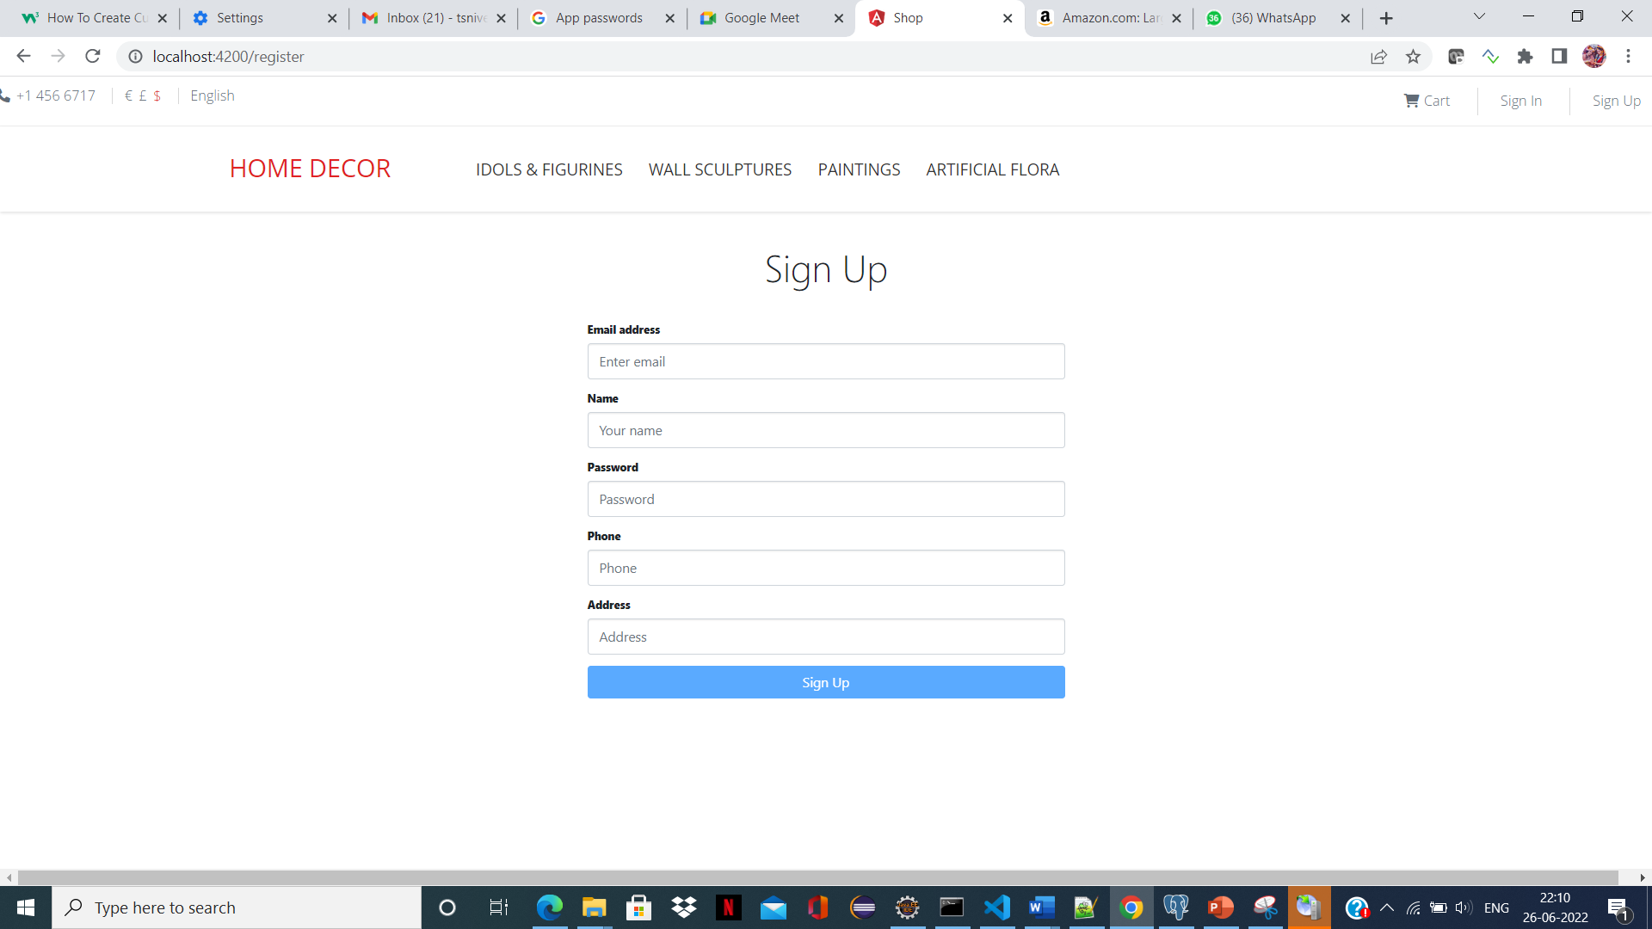

Sign Up page

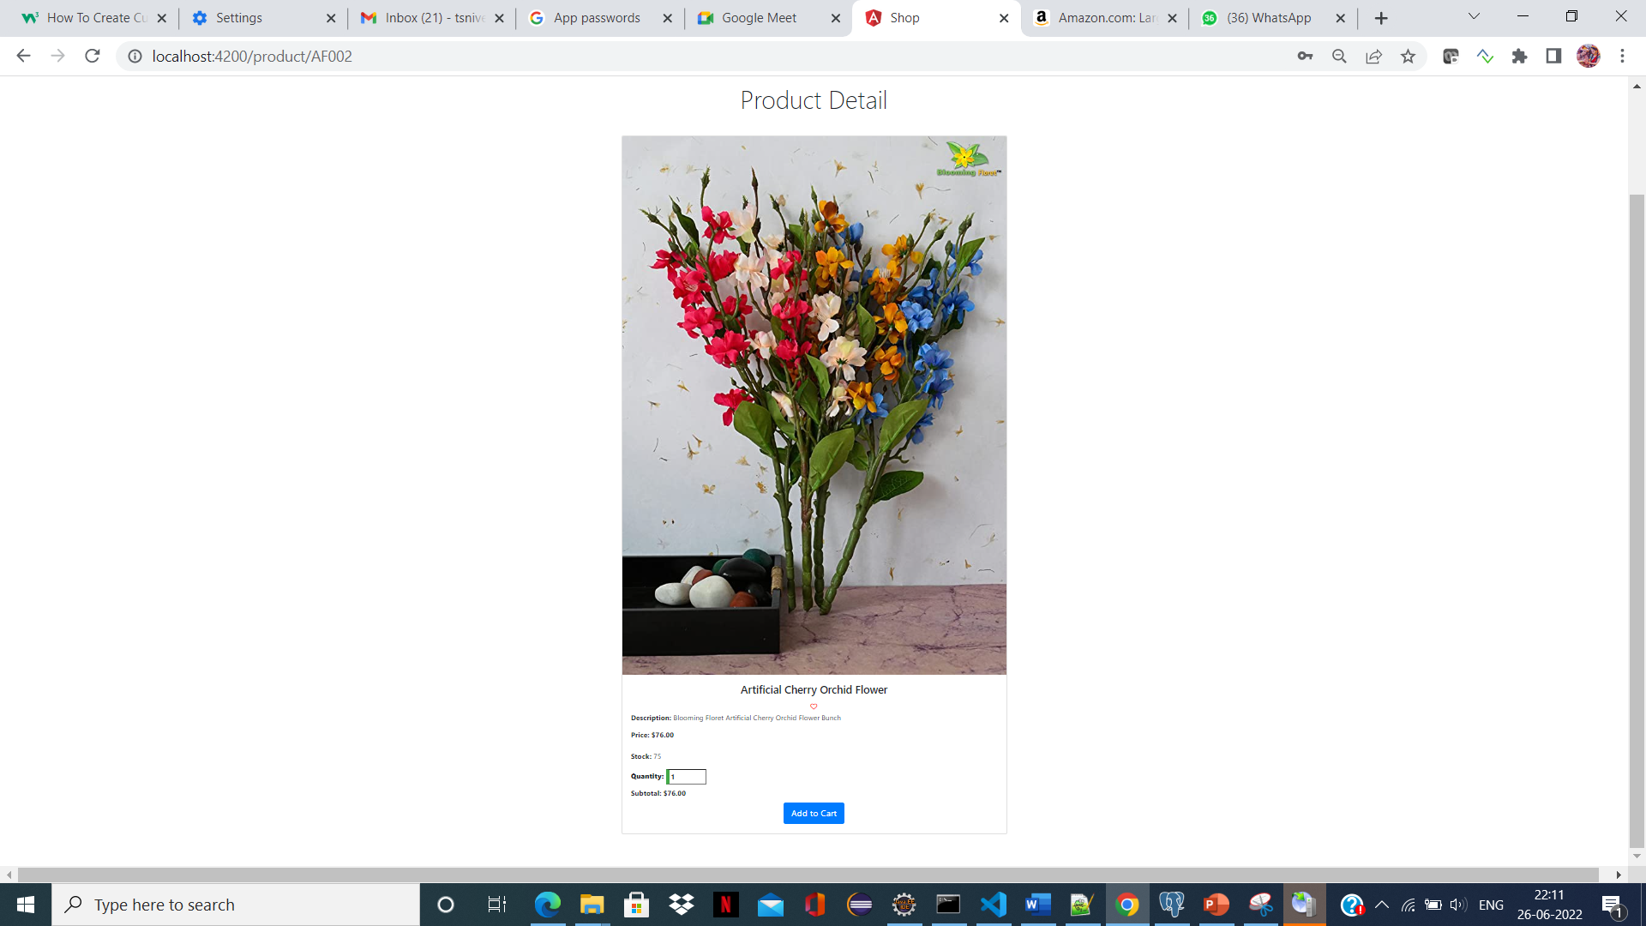

Product Details page

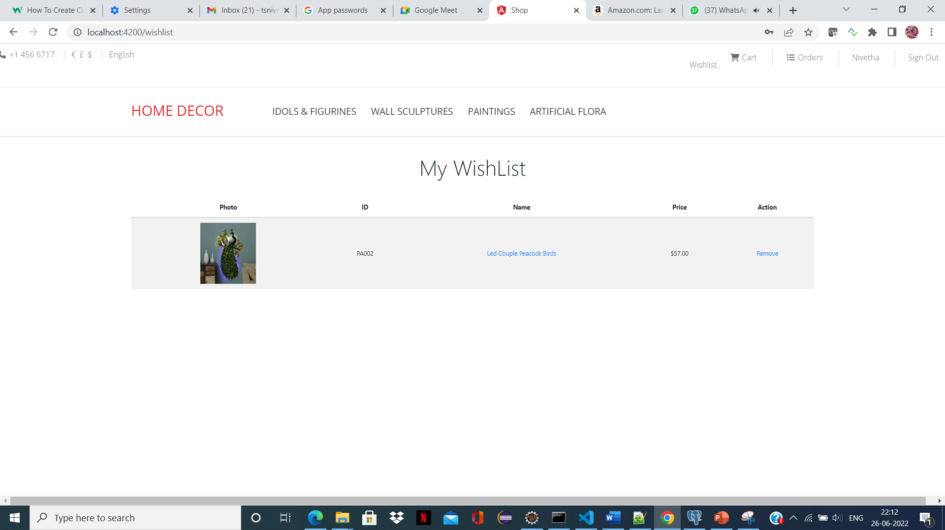

WishList page

ADMIN FUNCTIONALITY:

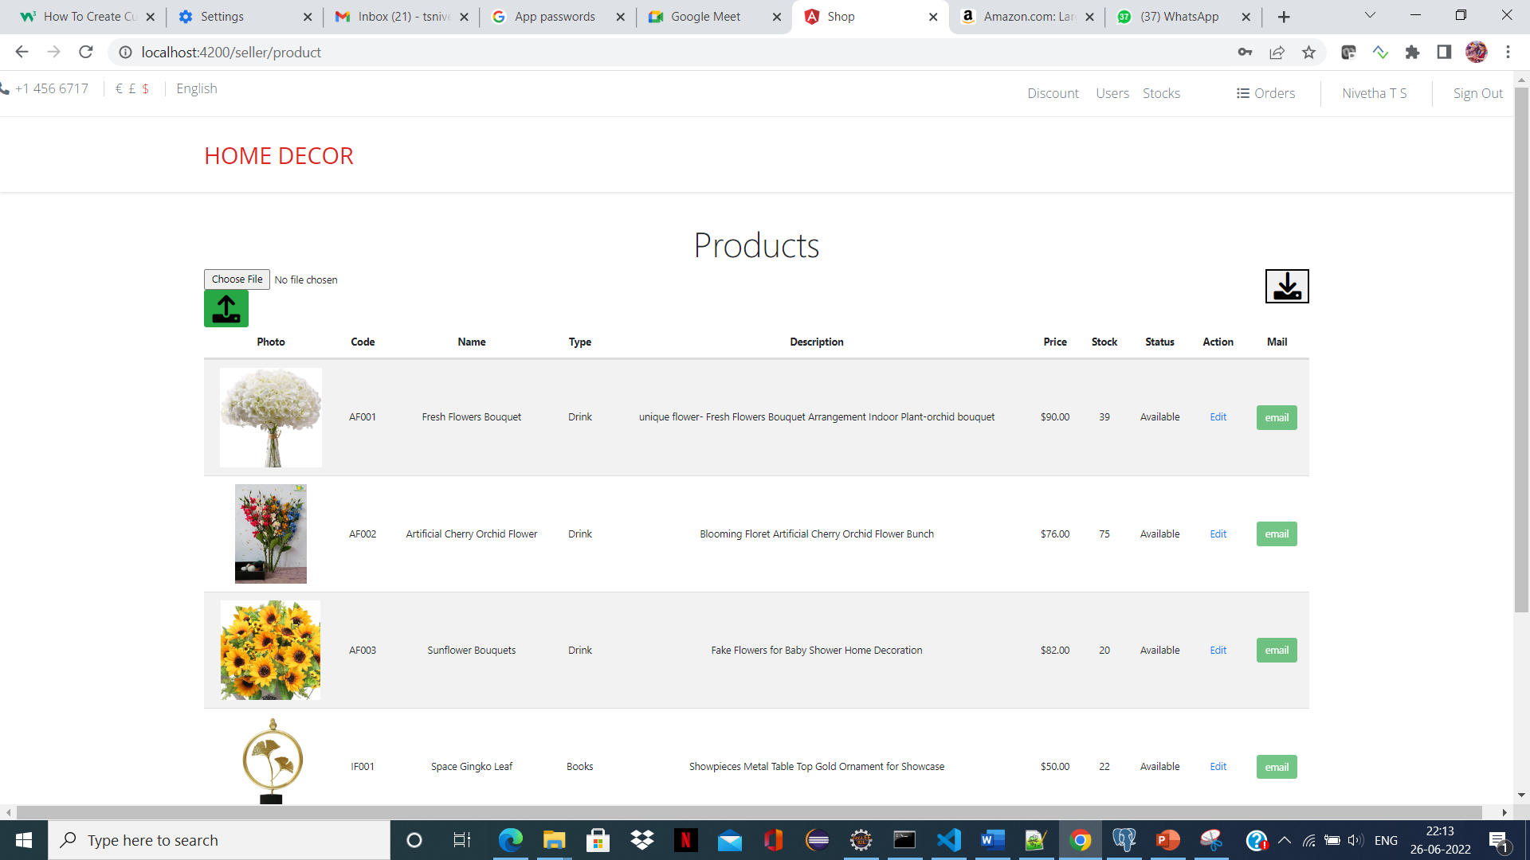

Stock page

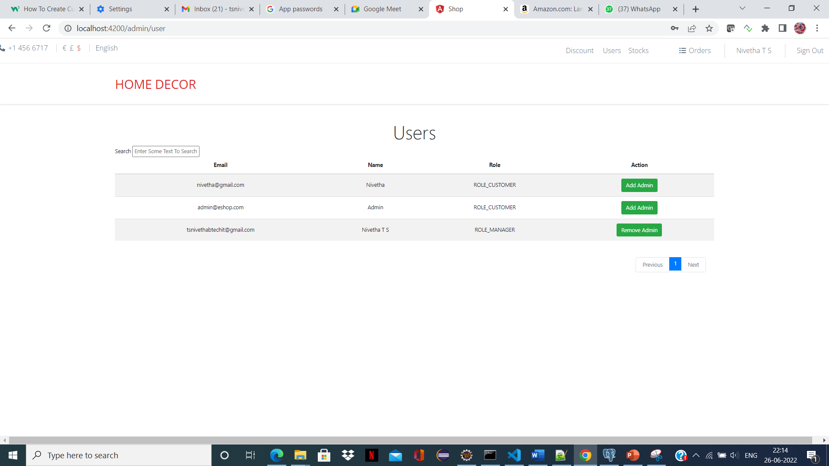

User view page

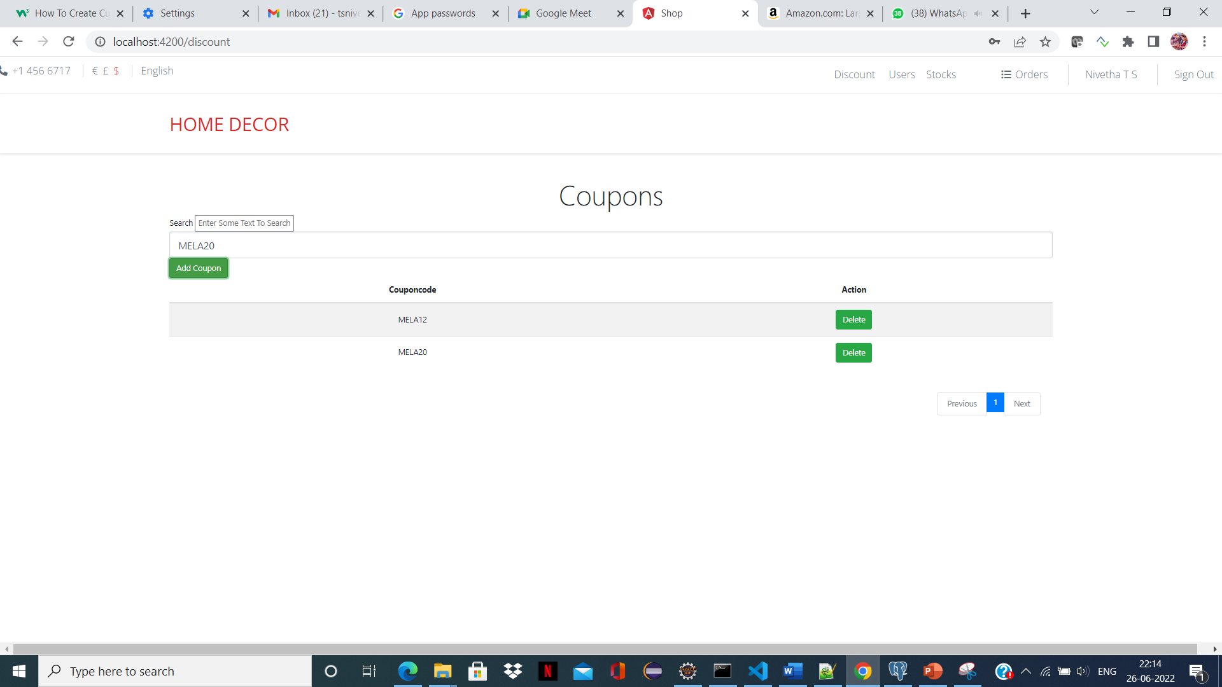

Discount page

**BACKEND SCREENSHOTS**

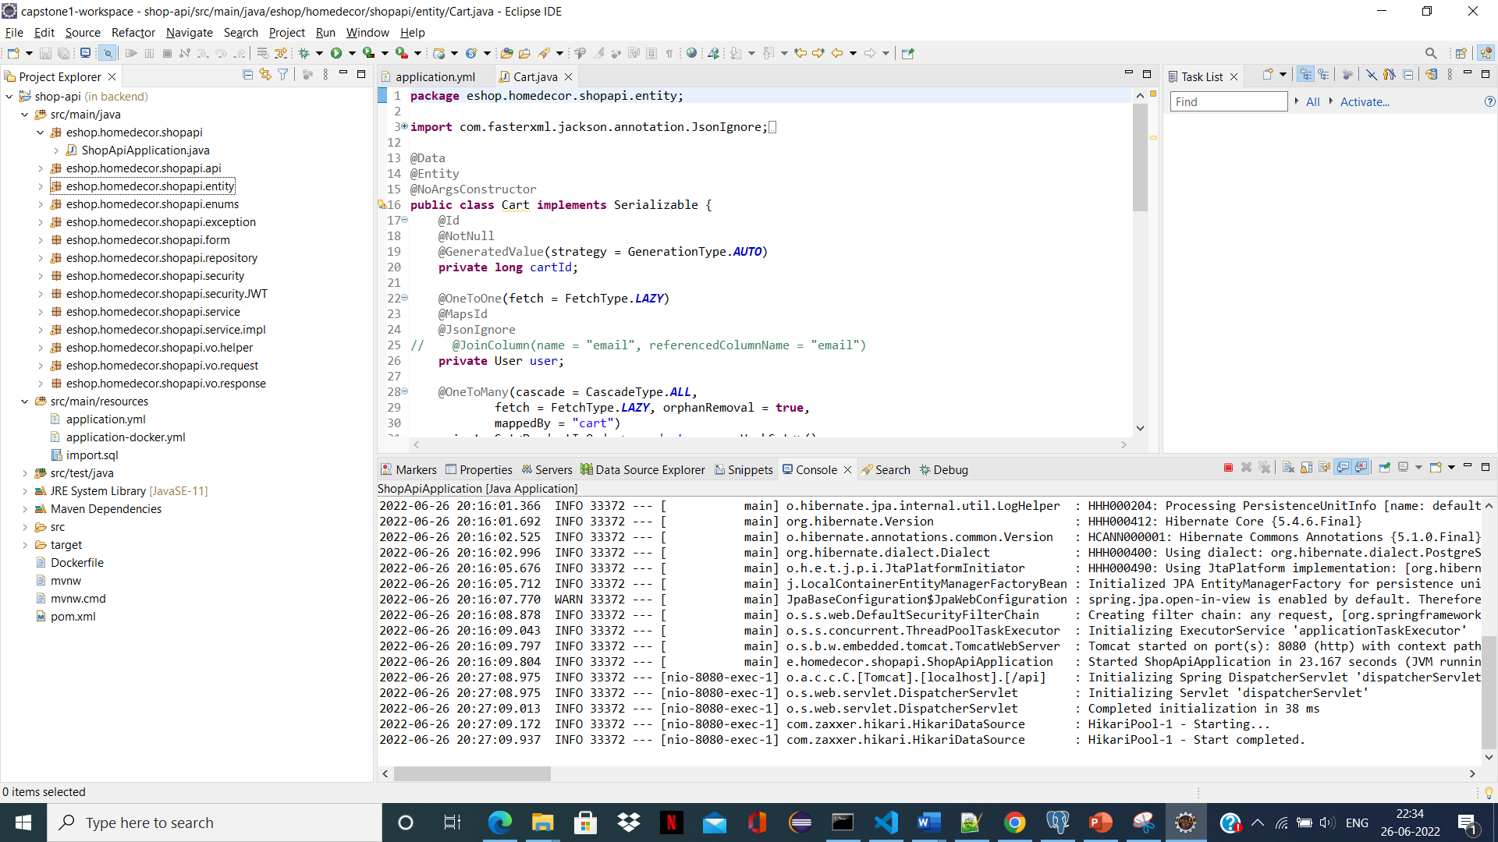

Backend Structure

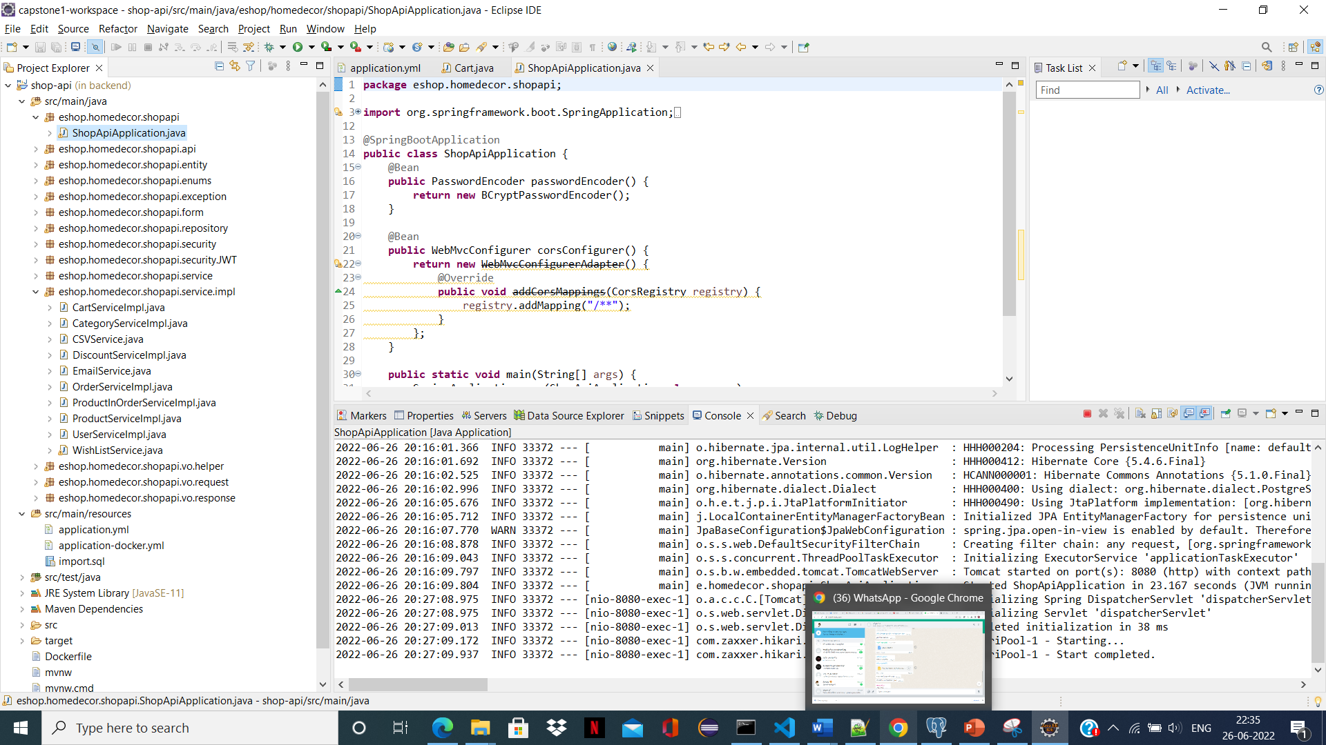

Service page

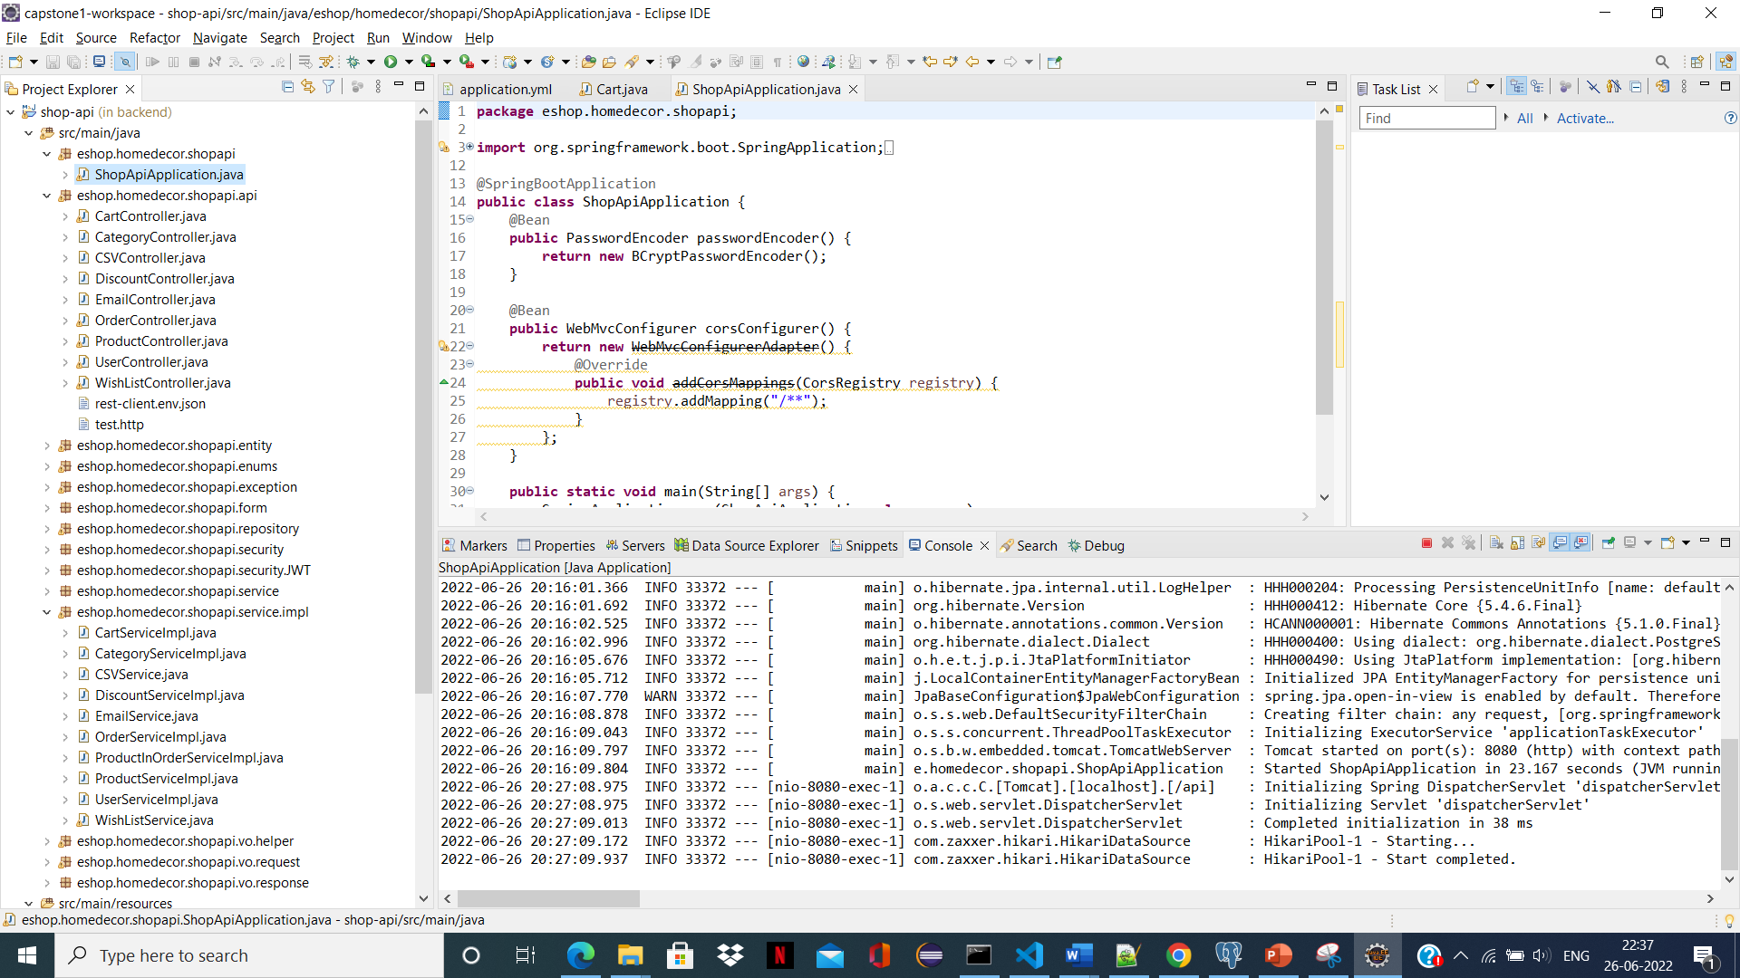

Api page

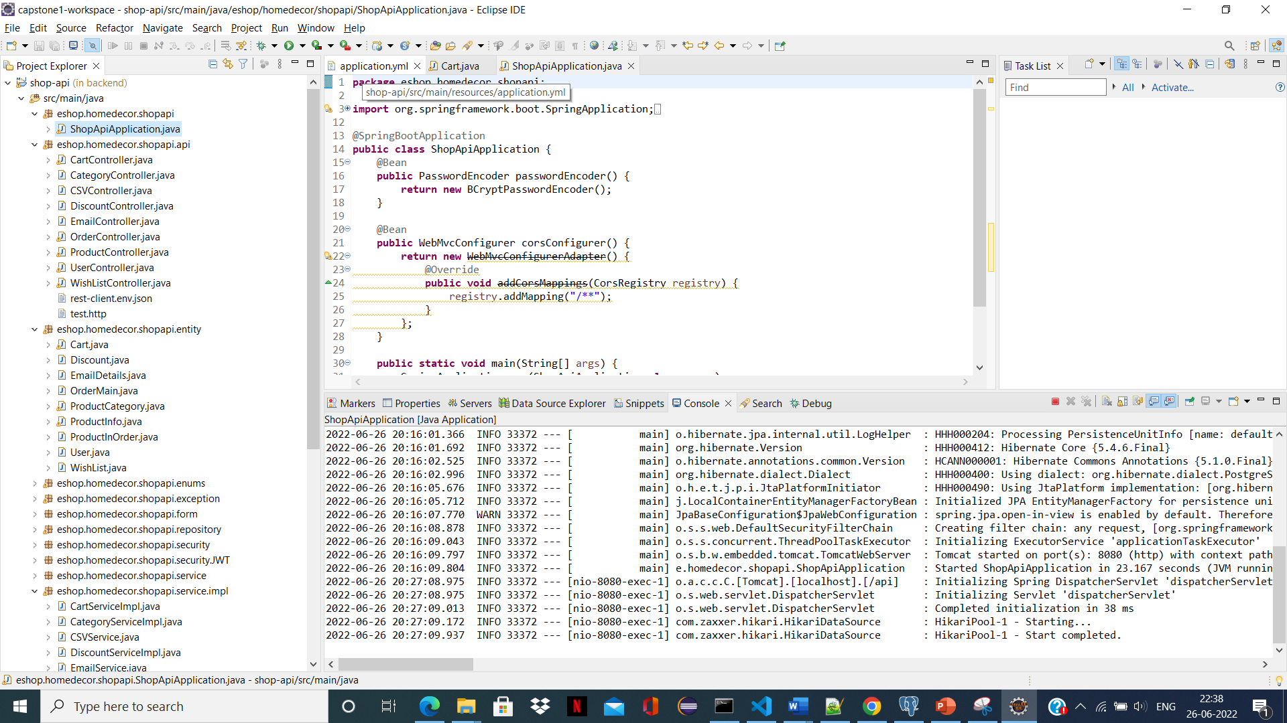

Entity page

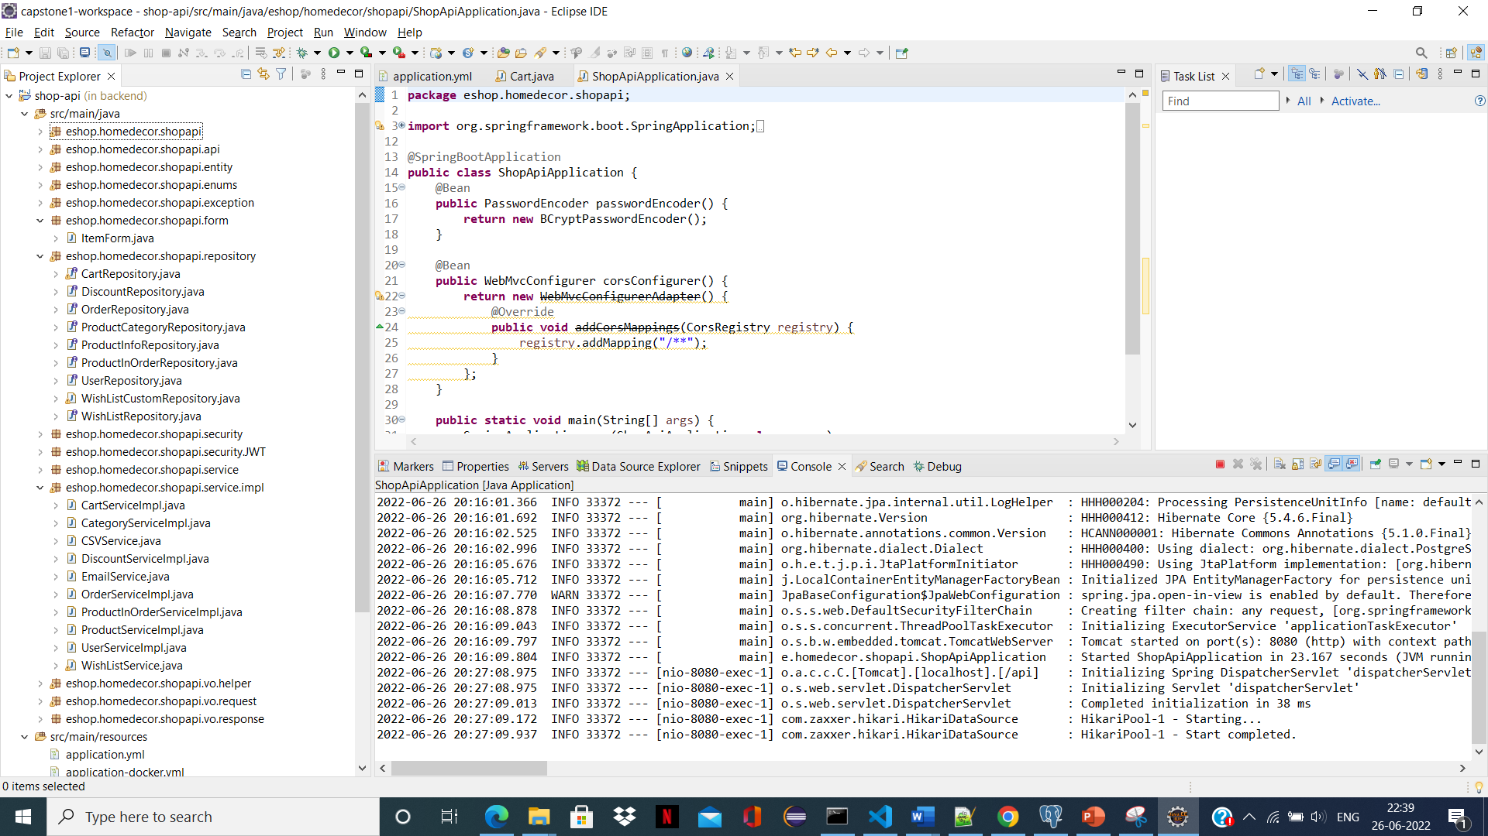

Repository page

**8. CONCLUSION AND FUTURE ENHANCEMENTS**

**8.1 CONCLUSION :**

E-Commerce has undeniably become an important part of our society. The successful companies of the future will be those that take E-Commerce seriously, dedicating sufficient resources to its development. E-Commerce is not an IT issue but a whole business undertaking. Companies that use it as a reason for completely re-designing their business processes are likely to reap the greatest benefits. Moreover, E-Commerce is a helpful technology that gives the consumer access to business and companies all over the world.

**8.2 FUTURE ENHANCEMENTS :**

The e-commerce industry saw major traction in 2020. Technology innovation, easy scalability, increased internet penetration and changed user habits due to COVID-19 let the industry improve experiences and compete against brick-and-mortar shops. Engaging customers directly is top priority for brands, and in this era of widespread awareness and cutthroat competition, the only way to survive is to stay ahead of the curve, identify lagging areas and capture evolving trends at the onset.

1. **REFERENCES**

[1] Albert H., Judd, Rivers, (2006) “Creating a winning E-Business”, Wagner Course Technology Thomson Learning, pp. 37-255.

[2] Alawneh A., and Hattab E, (2007) “E-Business Value Creation: An Exploratory Study, Proceedings of the Seventh International Conference on Electronic Business”, Taipei, pp. 181-188.

[3] Alawneh A., and Hattab E (2009). “International Arab Journal of eTechnology”, Vol. 1, No. 2, pp. 1-8

[4] Amit B. and Steve M. (2007), “How to Plan E-Business Initiatives in Established Companies”, Vol. 49, No. 1, pp. 11-22

[5] Aranda-M., G. and Stewart, P. (2005), “Barriers to E-Business Adoption in construction international literature review”, pp. 33-49

[6] Ayo, Charles K. (2006). “The Prospects of e-Commerce Implementation in Nigeria, Journal of Internet Banking and Commerce”, Vol. 11, No.3, pp. 68-75 [7] Amar. K., Sohani, (2009), “Technology and Banking Sector”, ICFAI University Press, pp. 1-39

[8] Brahm C., (2009) “E-Business and Commerce Strategic Thinking and Practice”, Houghton Mifflin, pp. 114-312.

[9] Chiemeke, S. C., Evwiekpaefe, A. and Chete, F. (2006), “The Adoption of Internet Banking in Nigeria: An Empirical Investigation, Journal of Internet Banking and Commerce”, vol. 11, No.3, pp 33-49

[10] David W, (2001) “E-Commerce Strategy, Technologies and Applications”, Tata McGraw Hill, pp. 3-143.

[11] Daft, Richard L. (1982), “ Bureaucratic Versus Nonbureaucratic Structure and the process of Innovation and Change”, pp. 129-166

[12] Earl, M. (2000), “Evolving the E-Business, Business Strategy Review”, pp. 33-38

[13] Eben.O (2003) “A Systematic Approach to E-Business Security”, pp. 87-103 [14] Hackbarth, G. & Kettinger W. J. (2000), “Building an E-Business Strategy: Information Systems Management” pp. 78-90.

[15] Kalakota, R. and Robinson M. (1999), “E-Business: Roadmap for success”, Addison-Wesley, 112-149 19

[16] Karjaluoto H., Mattila M. (2002). “Electronic Banking in Finland: Consumer Beliefs and Reactions to a New Delivery Channel, Journal of Financial Services Marketing”, Vol. 6, No. 4, 2002, pp. 346–361

[17] Laudon, K. and Traver, C. (2008), “ E-Commerce: Business, Technology, Society”, 4th Edition, Prentice Hall, pp.48-67

[18] Melao, N. (2008), “ E-Business Processes and E-Business Process Modeling: A State-of-the-Art Overview”, pp. 54-89

[19] Mendo, F. and Fitzgerald, G. (2005), “Theoretical Approaches to Study SMEs E-Business Progression”, Journal of Computing and Information Technology, Vol. 13, No. 02, pp. 123-136

[20] Namita.R (2011). “Global Journal of Enterprise Information System”, Vol. 3, No. 1, pp. 17-31

[21] Peterson O,(2009), “Communications of the IBIMA”, Vol. 8, Issue No. 3, pp. 175-190

[22] Poon S. & Swatam (1997), “Small business use of Internet: Findings from Australian case studies”, Internation Marketing Review. Pp. 385-403

[23] Poon S. and Swatman P., (1999) “An exploratory study of small business Internet commerce issues”, Information and Management, Vol. 35, pp. 9-18.

[24] P.T. Joseph, S.J., (2009) “E-Commerce An Indian Perspective”, PHI, pp. 304- 503.

[25] Rafiu, Oyesola S. (2007). “The Emergence of Internet Banking in Nigeria: An Appraisal, Information Technology Journal”, Vol. 6, No. 4, 2007, pp. 490-496

[26] Rahmath S., Hema D. and Abdullah K. (2011). “International Arab Journal of e-Technology”, Vol. 2, No. 1, pp.56-64

[27] Rajesh P., (2009), “Indian Banking and Globalization”, Adhyayan Pub., pp. 33-88

[28] Ramboll Management ‘ICT and E-Business Impact in the Banking Industry’, Version 4.0, 2008.

[29] Ravikumar Jain B., Krishna Kishore P., (2008), “Internet Banking”, ICFAI University Press, 69-88

[30] Reginald M., Norman C. and Stanislous Z. (2011), “African Journal of Business Management”, Vol. 5, No. 4, pp. 1857-1863